Korean Title

- Subtitle -

**Put the English Title of Paper Here.**

**Korean name (Submit without author names)**

English name (Submit without author names) 

|  |
| --- |
| **Abstract** (Write within 150-200 words) Reference numbers, figures, or tables should not be included in Korean and English abstracts. The abstract should include the research purpose, research method, research results, conclusion, and significance. The author's name must be deleted when submitting. When publication is confirmed, author information should be written as follows. Korean author names should be written in Korean name order, and English names should be written in First name Last name order directly below. The author's affiliation[1]* should be written as a footnote and distinguished by the number of asterisks in superscript. Distinguish the first author, corresponding author, etc. in a footnote at the bottom of the paper, and include their email. On the line below, enter the position at the affiliated institution, institution name, and department name. After the Korean abstract, 5-7 Korean keywords should be entered in a single line. After the English abstract, 5-7 English keywords should be entered so as not to exceed 1 line  ***Key words:*** Times New Roman 7.5pt Condensed by 0.15pt  초록 (120-160단어 이내로 작성) 한글 및 영문초록에는 참고문헌 번호를 인용하거나 그림 또는 표를 포함해서는 안된다. 초록의 내용은 연구 목적, 연구 방법, 연구 결과, 결론, 의의를 포함해야 한다. 저자명은 투고시 반드시 삭제하여 제출한다. 게재 확정이 되면 저자 작성은 다음과 같이 한다. 한글 저자명은 한글이름순으로 작성하고, 바로 아래에 영문은 First name Last name의 순서로 기입한다. 저자의 소속은 주석으로 작성하며 윗 첨자의 별 개수로 구별한다. 논문 하단의 주석으로 제1저자, 교신 저자 등을 구별하고, 이메일을 적는다. 아래줄에 소속기관에서의 직급, 기관명, 부처명을 기입한다. 한글 초록의 다음에 한글 주요어를 5~7개로 기입하되 1줄을 넘지 않도록 한다. 영문 초록의 다음에 영문 주요어를 5~7개로 기입하되 1줄을 넘지 않도록 한다.  주제어: (5-7개 작성) Korean Keywords in Times New Roman 7.5pt condensed by 0.5pt |
|  |

**Ⅰ. Times New Roman Bold 14pt Condensed by 0.2pt**

1. Times New Roman 11.5pt Condensed by 0.2pt

1) Times New Roman 10.5pt Condensed by 0.2pt

(1) Times New Roman 10pt Condensed by 0.2pt

1. Times New Roman 10pt Condensed by 0.2pt indentation 1.76cm

When writing in English, use Times New Roman 10pt with letter condensed by 0.25pt. Indent the second line and beyond by 0.35cm. References should follow APA 7th (American Psychology Association 7th) style.

Quotation Times New Roman 9pt Condensed by 0.15pt

<Table 1> Times New Roman 9pt Scale 95% Condensed by 0.35pt

|  |  |
| --- | --- |
| **Type** | **Only the first word capitalized. Times New Roman Bold 9pt Scale 95% Condensed by 0.35pt** |
| Open | Only the first word capitalized. Times New Roman 9pt Scale 95% Condensed by 0.35pt |

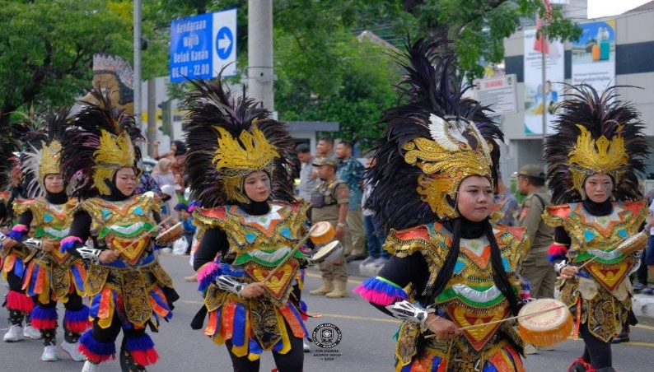

**[Figure 1]** Times New Roman 9pt Scale 97% Condensed by 0.25pt

**References**

References should be written in English. Times New Roman 10pt Condensed by 0.25pt

Author (Year of Publication). *Book Title*. Publisher.

Author (Year of Publication). Paper Title. *Publication Name, Volume*(Issue), Pages. DOI

1. * Author. Submit without author’s name. Times New Roman 8pt

   Received: 2 February 2025, Reviewed (Revised): 2 April (7 April) 2025, Accepted: 7 April 2025  
   © 2025 Korean Music Education Society.